Jump for Jersey Derby & Dressage!
Wednesday August 30th &
Sunday October 15, 2017
At the Horse Park of New Jersey
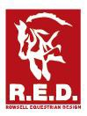
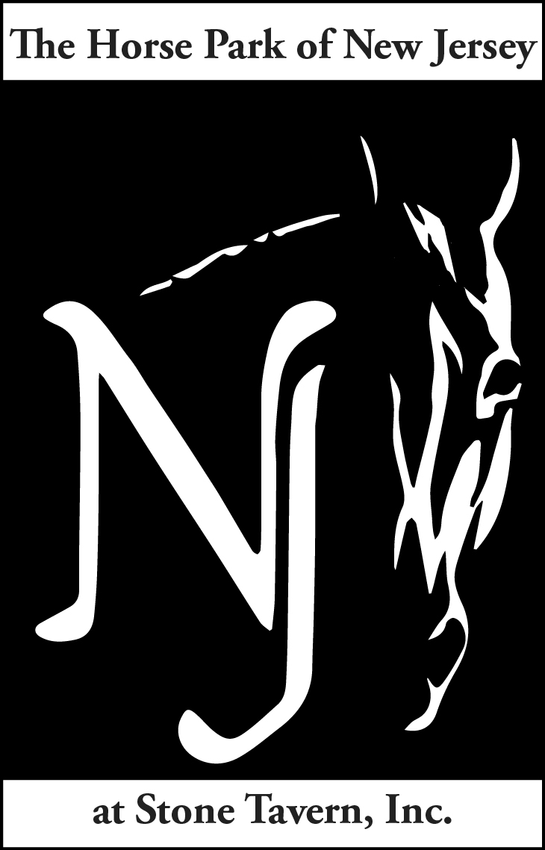
An Event Derby at the Horse Park of NJ to benefit

LEVEL |  | HEIGHT HHHhhhHEIGHTHEIGHT | SPEED
Novice |  | 2’11” | 400 MPM
Beginner Novice |  | 2’7” | 350 MPM
Starter |  | 2’3” | 300 MPM

Event Derby Format & Rules:
This is a fun combination of show jumping and XC fences in our arenas. Any round over the optimum time allowed or under the speed fault time allowed will incur 1 penalty point per second. Rails are 5 penalty points. Refusals are 20 penalty points. Falls are elimination. There will be 1 “Joker fence”. The Joker fence will erase 1 rail OR 5 seconds of time. Decision of rider to take the Joker Fence must be made while on course. Clean rounds will move forward to a jump-off, fastest time wins. Joker Fence option will be included in jump off. Ties broken by time closest to Optimum time.
Required: USEA Approved Cross Country safety vest and helmet. Half -chaps acceptable.
USEF rules regarding Safety and Conduct will be followed.

Dressage: Fix-a-test format with Judge Jane Cory. Choose which Event or regular dressage test you will be riding and indicate it on your entry form.

Fees & Prizes:
Derby: First round is $60 which includes the jump-off round (HPNJ members only $50!) A second round at the same or another level (same horse & rider combination) is $20. Coaching allowed in second rounds, but second rounds not eligible for prizes. Ribbons to 8th place. Second rounds may be post entered at the Derby. You may sign up to become a member that day, BEFORE riding!
Dressage: $25 per test; $20 for HPNJ Members. Ribbons to 6th place at each level (BN, N, T, etc).

Schedule: Blocks of time will be assigned per level. Posted on Sunday, 8/27 & Wednesday, 10/11 on www.jfi3d.com.

Other: Entry forms at www.horseparkofnj.com. Call 609-259-0170 to pay by credit card. Checks payable to JFI 3Day and mailed to Horse Park of New Jersey 626 Rt 524 Allentown, NJ 08501 ATT:Derby. Late and Post entries incur a $20 late fee (after Aug 24, or Oct 9).
Not yet a HPNJ member? You may sign up to become a member on Derby Day, BEFORE RIDING to receive the member rate! This offer is for active, business, professional and life members.
Special HPNJ Member Discount!

