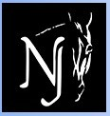
Dressage at Stone Tavern II
626 Route 524, Allentown, NJ 08501
September 9, USEF/USDF #315027 – Level #2

2017 Col. Bengt Ljungquist Memorial Championship (BLM) Qualifying Competition
2017 Great American Insurance Group/USDF Qualifying Competition

SHOW DATES OPENING DATE CLOSING DATE
September 9, 2017 July 18, 2017 August 22, 2017

MANAGERS: SECRETARY:
Jane Cory Debra McCluskey
215-262-2870 609-203-6142
Jane@pleasanthollow.com DebraLMcCluskey@yahoo.com
Jennifer Bateman
215-804-6432 MAIL ENTRIES TO:
Horse Park of NJ, 626 Route 524
SHOW MANAGEMENT: Allentown, NJ 08501
Horse Park of NJ
www.horseparkofnewjersey.com VET:
Foundation Equine – on call
SHOW COMMITTEE: 609-291-0535
Lynn Mathews
Debra McCluskey FARRIER:
Jennifer Bateman Tom Picinich – on call
732-685-1509
SHOW OFFICE PHONE:
215-804-6432(show days only) EMT SERVICES:
New Egypt Ambulance
STABLE MANAGER:
TBA TD: Camille Kopcik, R, NY

JUDGES: Marilyn Payne, S, NJ
Susan Graham-White, R, MD

DRESSAGE AT STONE TAVERN II CLASS LIST
Every class offered herein which is covered by the rules and specifications of the current USEF Rule Book will be conducted and judged in accordance therewith. USEF tests, Current editions.
Saturday, September 9th
01  02 | Training Level Test 1-Open  Training Level Test 2-Open /BLM
03 | Training Level Test 3- O/GAIG/USDFQ
04 | Training Level Rider Test
11 | First Level Test 1-Open
12 | First Level Test 2-Open/BLM
13 | First Level Test 3- O/GAIG/USDFQ
14 | First Level Rider Test
21 | Second Level Test 1-Open
22 | Second Level Test 2-Open/BLM
23  24 | Second Level Test 3- O/GAIG/USDFQ  Second Level Rider Test
31 | Third Level Test 1-Open
32 | Third Level Test 2-Open/BLM
33 | Third Level Test 3-Open/GAIG/USDFQ
41 | Fourth Level Test 1-Open
42 | Fourth Level Test 2-Open/BLM
43 | Fourth Level Test 3 – O/GAIG/USDFQ
50 | FEI PSG-Open/BLM/GAIG/USDFQ
51 | FEI Intermediare I-Open/BLM/GAIG/USDFQ
52 | FEI Intermediare II-Open/BLM/GAIG/USDFQ
53 | FEI Gr Prix Test-Open/BLM/GAIG/USDFQ
54 | FEI Test for 5-6 yr olds – O+
55 | FEI YR Ind. Test
56 | FEI Jr or Pony TOC – GAIG/USDFQ++
57 | FEI TOC+ - GAIG/USDFQ
58 | FEI IPEC- TOC+
59 | USEF 4 yr old test
60 | USDF MFS- Open/(1st-4th)BLM/GAIG/USDFQ
61 | USDF Pas de Deux+
70  100  200  300 | FEI MFS-O/BLM/GAIG/USDFQ+  USDF Introductory Level Test A  USDF Introductory Level Test B  USDF Introductory Level Test C
+ Please specify test of choice. ++Only FEI Junior Team test may be ridden as qualifier for GAIG/USDF Regional Championship. No other qualifying test for this class may be accepted.
Please state on entry whether riding Open, BLM, or GAIG/USDF Qualifying and status of Amateur, Open, or JR. Management reserves the right to split, cancel, or combine classes. GAIG classes are 2017: If entering as Great American/USDF Qualifying, please indicate on your entry form your rider status and include the $10 Qualifying fee. Classes 57 FEI tests not offered.

Entry Fees – make check payable to Horse Park of NJ in US currently ONLY
REQUIRED FEES-All entries should include these fees
Class Fees:
Training thru Fourth Level $40
FEI Level Classes $50
USDF Musical Freestyles $50
FEI Musical Freestyles; Pas de Deux $55
Introductory Level Classes $30
Federation Fee: ($8 drug fee & $8 USEF fee) $16/horse
Office Fee (Non-Refundable) $30/entry
Additional Fees:
GAIG/USDF Qualifying – additional per class $10/class
USEF Show Pass (Rider/Owner/Trainer) $30
USDF Non-Member Fee $25
USDF Horse ID $25
Secretary Verification of Documents (ONLY applied if entry is incomplete) $10
Class Change, if granted by show secretary $10 per change
Non-competing Horse Fee (includes office fee) $40
Post Entry Surcharge: $30
(Applies to all entries RECEIVED after the closing date)
Stabling/Tack Stall for entire weekend (arrive Fri depart Sun) $135
Stabling/Tack Stall - day stall (must depart by 8 pm) $50
Shavings pre-ordered $7/bag
Shavings on-site $8/bag
Haul-in Fee (non-stabled horses) $15/day
Camper hook-up $45

ENTRIES: Mail entries to Horse Park of NJ as listed. Make check payable to Horse Park of NJ. Payment in US currency only. Entries also accepted online through EquestrianEntries.com. Entries must be received by the closing date or $30 late fee is applied. Illegible or incomplete entries may be returned. All entries must be typed or printed on an official USEF/USDF entry form and include: original handwritten signatures (owner, rider, trainer and coach, if applicable), photo- copy of negative Coggins test dated within 12 months of show date, proof of vaccination per GR 845, and copies of USEF and USDF membership or identification cards for each owner, rider, trainer, and horse, as applicable. Emergency number must be included. A $10 fee will be assessed for secretary printing missing or incorrect information. No refunds after closing date or for “acts of god” which require management to cancel classes or day(s) of competition.

TIMES: Times will be on the website www.horseparkofnewjersey.com and at http://www.foxvillage.com. Complete prize list is available at www.horseparkofnewjersey.com.

AWARDS: (ONLY tests will be mailed post competition)
Award and ribbons 1-6 awarded each division (min 3 entries)
Champion award and Reserve Champion ribbon per level.

STABLING: 10’ x 10’ temporary stalls, stall door provided. See the above fee schedule for information. Day stalls must be vacated by 8 pm same day of use; must purchase full weekend stabling to stable overnight. Please indicate stabling concerns on entry form.

FOOTING: Standard outdoor competition rings (sand/screenings mixture); indoor ring is sand. Separate ring for lunging.

ACCOMODATIONS: Hampton Inn 609-426-1600, ask for Special Horse Park of NJ rate. See horseparkofnewjersey.com for others.

PROFESSIONAL SERVICES: Contact numbers posted the day of the show in the secretary stand.
An EMT/Med Tech will be on grounds. Vet and Farrier will be on call.

DIRECTIONS: 626 Route 524, Allentown, NJ 08501, Take I-195 to Exit 11, follow signs for Horse Park of NJ.

OTHER: Food available on grounds. Dogs MUST be leashed at all times.

ATTENTION COMPETITORS
Each competitor is responsible for supplying management with correct applicable numbers (USDF and USEF) for horse, owner, rider, and trainer before the day(s) of the competition. The scores of competitors who fail to supply correct numbers may not be counted toward national awards.

If a competitor is a no-show for their first test of the competition they will be scratched from their remaining tests.

Sharps Containers: Show management will provide one sharps container per 50 stabled horses, per USEF rule 1211.5. Competition Management may fine any individuals including trainers, owners, exhibitors, or their agents up to $100 for improper disposal of needles or other sharp disposable instruments.

USEF rules go into effect upon arrival at the show grounds. Per DR120.1-6 PROTECTIVE HEADGEAR MUST BE WORN AT ALL TIMES WHEN MOUNTED. Bridle numbers must be worn at all times when a horse is out of stall or trailer.

HOLD HARMLESS CLAUSE: Understanding that horse sports may be hazardous and dangerous, even leading to permanent injury or death, each owner, rider, spectator, and other participant assumes any and all risk of loss or injury and agrees to hold harmless, regardless of negligent acts or omissions The Horse Park of New Jersey, the show management, show committee, and all horse show personnel.

SHOW PASS FEE: Effective 12/1/2013, a non-member who wishes to participate in a USEF competition must pay a Show Pass fee in lieu of a USEF non-member fee. Please see GR 205 for additional information.

IMPORTANT NEW VACCINATION REQUIREMENTS
HPNJ in compliance with GR 845 will require proof of Equine Influenza Virus and Equine Herpes Virus vaccination for all horses entering the show grounds. Please read the rule below.
GR845 Equine Vaccination Rule
1. At Federation licensed competitions, horses entering the grounds must be accompanied by documentation of Equine Influenza Virus and Equine Herpes Virus (Rhinopneumonitis) vaccinations within six months prior to entering the stables. Horses not in compliance with this rule may be required to leave the competition grounds upon request by Competition Management. Documentation should consist of one of the following methods mentioned below. The frequency of vaccine administration should be per the vaccine manufacturers’ or veterinarian’s recommendations. It is recommended that vaccines are administered by or under the direction of a veterinarian.
2. In the case of vaccines administered by a veterinarian, the exhibitor, upon request by Competition Management, must provide documentation from the veterinarian on documenting that the horse in question received the vaccinations; name of the vaccines and date of vaccine administration.
3. In the case of vaccines administered by a person other than a veterinarian, the exhibitor, upon request by Competition Management, must provide a receipt of the vaccine purchase which is signed by the owner, or agent with care, custody, and control of the horse; name, serial number and expiration date of the vaccine; and date of vaccine administration.
4. In the case of a horse that is unable to receive either of the vaccinations due to a history of adverse reactions, the exhibitor, upon request by Competition Management, must provide a letter from the veterinarian on official letterhead stating that the horse in question cannot be vaccinated due to medical concerns and a log of temperatures taken twice daily for the seven days prior to entering the competition grounds. These horses must also have their temperature taken and logged twice daily while on the competition grounds. The log of temperatures should be provided to the Competition Management, steward, or technical delegate when requested.
5. Competition Management may not amend or enhance vaccination requirements without prior approval of the Veterinary Committee. BOD 1/17/15 Effective 12/1/15

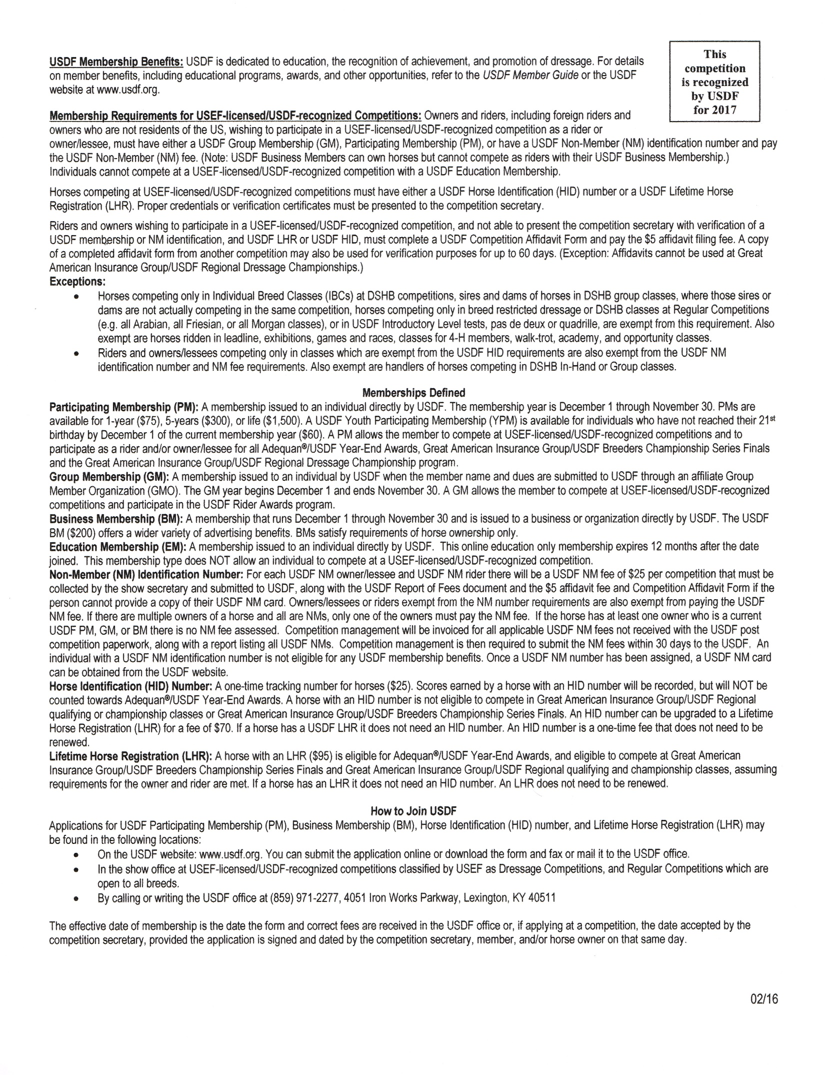
USDF Statement on Animal Welfare
The United States Dressage Federation, Inc. (USDF), a federation of over 100 independent organizations throughout the United States with a membership of nearly 30,000 members, supports the concept of ethical treatment of animals.
Dressage is a classical method of training horses, based upon the horse’s natural responses, as carried out in a gradual, planned program during which the horse’s athletic abilities are improved in a systematic manner. As a result, the horse becomes capable, comfortable, and responsive in partnership with the rider without the use of force. Dressage competition at various levels of achievement is the ultimate test of the training program to determine whether the desired harmony between horse and rider has been achieved.
The rules pertaining to dressage competition prohibit the use of artificial appliances, training aids, and drugs, which would force the horse to submit. Instead, the emphasis is upon training and a cooperative partnership with the rider. Major competitions are carefully monitored to assure that there is no unnecessary force or harshness displayed.
Unlike other horse sports in which horses enter training at a relatively immature state, dressage training is usually not seriously begun until the horse is three or four. The top levels of achievement require five or more years of progressive training and it is not unusual to see horses in international competition in their late teens. This, in itself, places a premium on good care and soundness throughout the horse’s life.
While supporting the concept of animal welfare in its broadest form, the United States Dressage Federation, Inc., also recognizes that it is unrealistic to ascribe human emotions and responses to the horse which in its wild state is a creature of flight, living a hard and precarious existence. Under domestication, the horse is assured of ample food, water, and shelter, as well as protection against infectious diseases and damaging parasites, thus leading a longer and healthier life with a high rate of survival.
As an educational organization, USDF has numerous programs, which teach people how to pursue the accepted, humane training methods. A program of certifying instructors also emphasizes protecting the horse’s welfare in pursuit of dressage training. United States Dressage Federation 4051 Iron Works Parkway, Lexington, KY 40511 Phone: 859-971-2277, Fax: 859-971-7722, usdressage@usdf.org

Motor Vehicle Statement
Minors who do not have a valid driver's license which allows them to operate a motorized vehicle in the state in which they reside will not be permitted to operate a motorized vehicle of any kind, including, but not limited to, golf carts, motorcycles, scooters, or farm utility vehicles, on the competition grounds of licensed competitions. Minors who have a valid temporary license may operate the above described motorized vehicles as long as they are accompanied by an adult with a valid driver's license. The parent(s), legal guardian(s), or individual who signs the entry blank as a parent or guardian of a minor operating a motorized vehicle in violation of this rule are solely responsible for any damages, claims, losses or actions resulting from that operation. Violations of this rule will be cause for sanctions against the parent(s), guardian(s) and/or trainer(s) who are responsible for the child committing the offense. Penalties may include exclusion of the child, parent(s), guardian(s), and/or trainer(s) from the competition grounds for the remainder of the competition and charges being filed against any of the above individuals in accordance with Chapter 6. Wheelchairs and other mobility assistance devices for individuals with disabilities are exempt from this rule

USEF MEMBERSHIP STATEMENT
Life, senior active and junior active members shall be eligible to participate in all classes at Regular Competitions, Eventing Competitions at the Preliminary Level or above and Combined Driving Competitions at the Advanced Level, Dressage, Reining and Vaulting Competitions and Endurance Rides. A nonmember may participate as a handler, rider, driver, owner, lessee, agent, coach or trainer at Regular Competitions, Eventing Competitions, Dressage Competitions, Reining Competitions and Combined Driving Competitions upon payment of a $30 Show Pass fee. Participants in the following classes are exempted from the Requirements of this rule: 1) leadline; 2) exhibitions; 3) games and races; 4) classes for 4-H members; 5) walk trot (exception: Friesian performance FR218) and academy classes (academy classes are classes limited to horses used regularly in a lesson program); 6) USDF introductory level tests, pas de deux and quadrille classes; 7) NRHA Endorsed Reining Competitions. 8) Opportunity classes, 9) citizens of other nations who have proof, in English, of current membership in good standing of their own National Federation, 10) USEA beginner novice division; and 11) assistant handlers in Dressage Sport Horse Breeding classes.
Additional Awards
NEW this year!!!
Topline Champion Challenge
Over $1500 in prizes
The Topline Champion Challenge is a series of ten events at three different venues. Adult Amateur and Professional awards offered: Training level through FEI. No fee in addition to Required Show Entry fees. Horse and rider combination must compete in 6 of 10 competitions at the same level to qualify. The six best scores of each horse and rider combination will be averaged and the highest average percentage will be champion at each level. Scratches will not count toward the average; if an Elimination must be counted, it will be awarded a “score” of 50.000% towards the average.

CHALLENGE ENTRY FORM – Can be found on all websites. Form is required to participate, must be submitted no later than September 1, 2017.

Best Turned-Out Award
Presented at end of competition, registration required.
$250 Musical Freestyle Challenge
sponsored by Jersey Palms Farm
$250 Musical Freestyle Challenge. Classes 60 and 70 ranked and pinned separately, but combined for prize money. Highest Percentage: $125; Second: $75; Third $50. No entry fee-automatic enrollment.

The Jockey Club T.I.P. High Point Thoroughbred Award
Will be awarded to the highest placing Thoroughbred in its division. TIP number must be provided with entry.

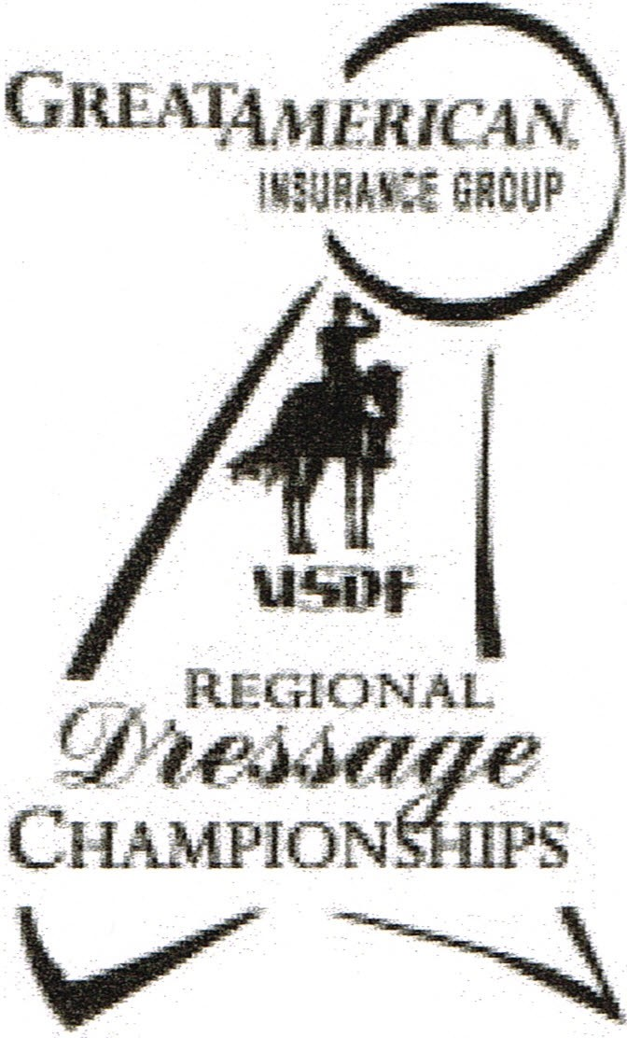
2017 Great American Insurance Group/USDF Regional Dressage Championships
A single Regional Dressage Championship program organized by the United States Dressage Federation (USDF), and recognized by the United States Equestrian Federation, Inc. (USEF), will be held in each of the nine USDF regions. In addition, Alaska and Hawaii may each hold state championships if an official request from a Group Member Organization (GMO) is received by April 1of the prior year. The Regional Championship Program Rules can be found on the USDF website at www .usdf.org. Please refer to the 2017 USDF Member Guide for the comprehensive list of rules and requirements for this program.

Membership/Registration Requirements for Qualifying and Championships
Rider:
- Must have a USDF Participating* Membership (PM) at the time qualifying scores are earned and at the time of the championships.
- Must have a USEF membership (Junior Active, Senior Active, or Life) at the time the qualifying scores are earned and at the time of the championships .
Horse:
- Must have a USDF Lifetime Horse Registration (LHR) at the time qualifying scores are earned and at the time of the championships.
- Must have a USEF (Annual or Lifetime) Membership recorded at the time qualifying scores are earned and at the time of the championships.
- USDF horse registration and USEF horse recording must be in the name(s) of the current owner(s) or lessee(s) of record.
- A horse is not required to have breed registry papers. Owner:
- Must have a USDF membership (PM* or Business Membership (BM)) at the time the qualifying scores are earned and at the time of the championships .
- Must have a USEF membership (Junior Active, Senior Active, or Life) at the time qualifying scores are earned and at the time of the championships.
* PMs are USDF members who join USDF directly . USDF Group Members (GM) are ineligible.

Minimum Qualifying Scores: One set of nationally-standardized qualifying scores has been established for all USEF/USDF Regional Championships, for Training Level through Grand Prix, in three divisions: open, adult amateur and junior/young rider. FEI Junior and FEI Young Rider classes have only one respective division. Freestyles have only open divisions.

The minimum percentages are as follows : | OPEN | AA | JRLYR
Training Level (Test 3) | 68% | 63% | 63%
First Level (Test 3) | 66% | 62% | 62%
Second Level (Test 3) | 64% | 61% | 61%
Third Level (Test 3) | 62% | 60% | 60%
Fourth Level (Test 3) | 62% | 60% | 60%
FEI Junior (Team Test) |  |  | 60%
FEI Young Rider (Team Test) |  |  | 60%
Prix St. Georges | 60% | 60% | 60%
Intermediate I | 60% | 60% | 60%
Intermediate II | 60% | 60% | 60%
Grand Prix | 60% | 60% | 60%
FREESTYLE | OPEN | AA | JRLYR
First Level | 63%
Second Level | 63%
Third Level | 63%
Fourth Level | 63%
Intermediate I | 63%
Grand Prix | 63% |  |  | Rev Feb 2016
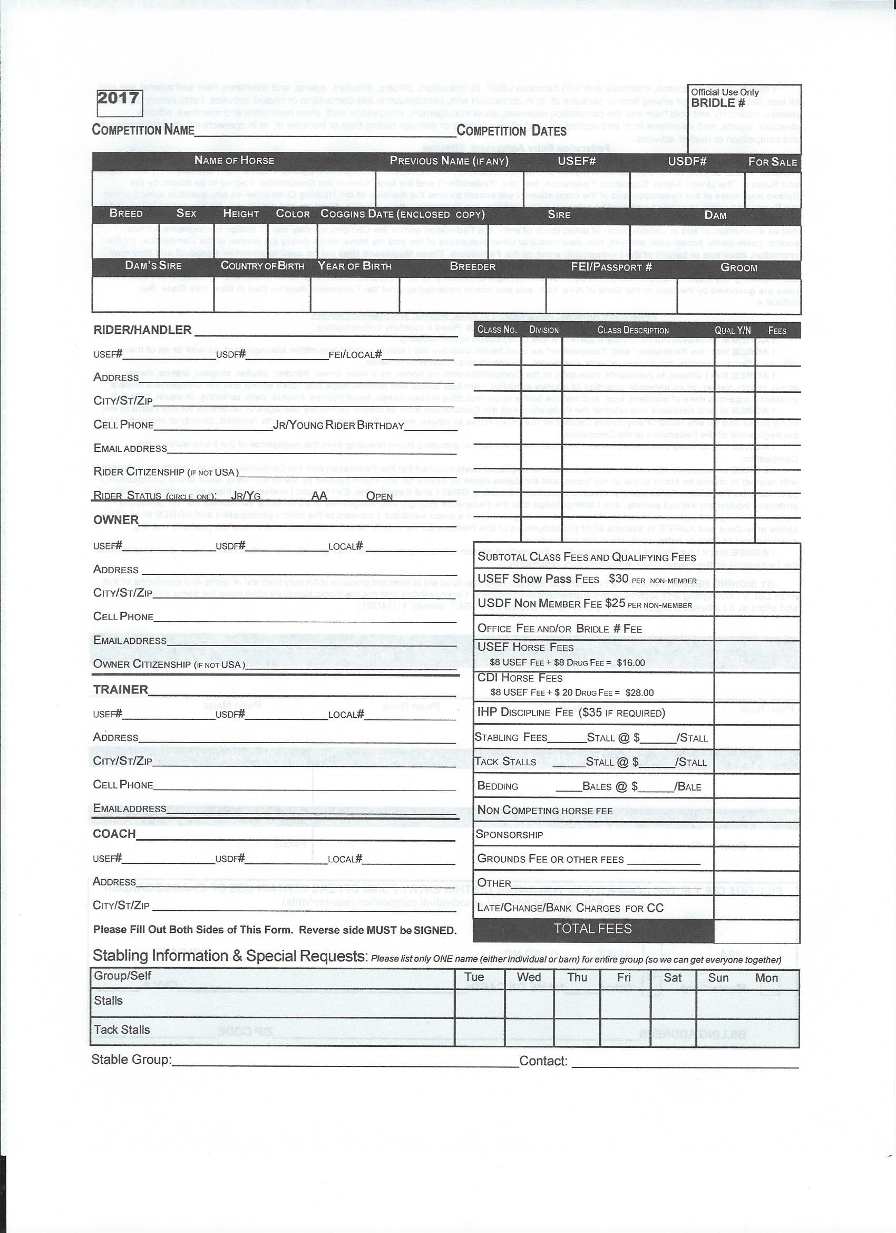
9/9/17
Dressage at Stone Tavern II
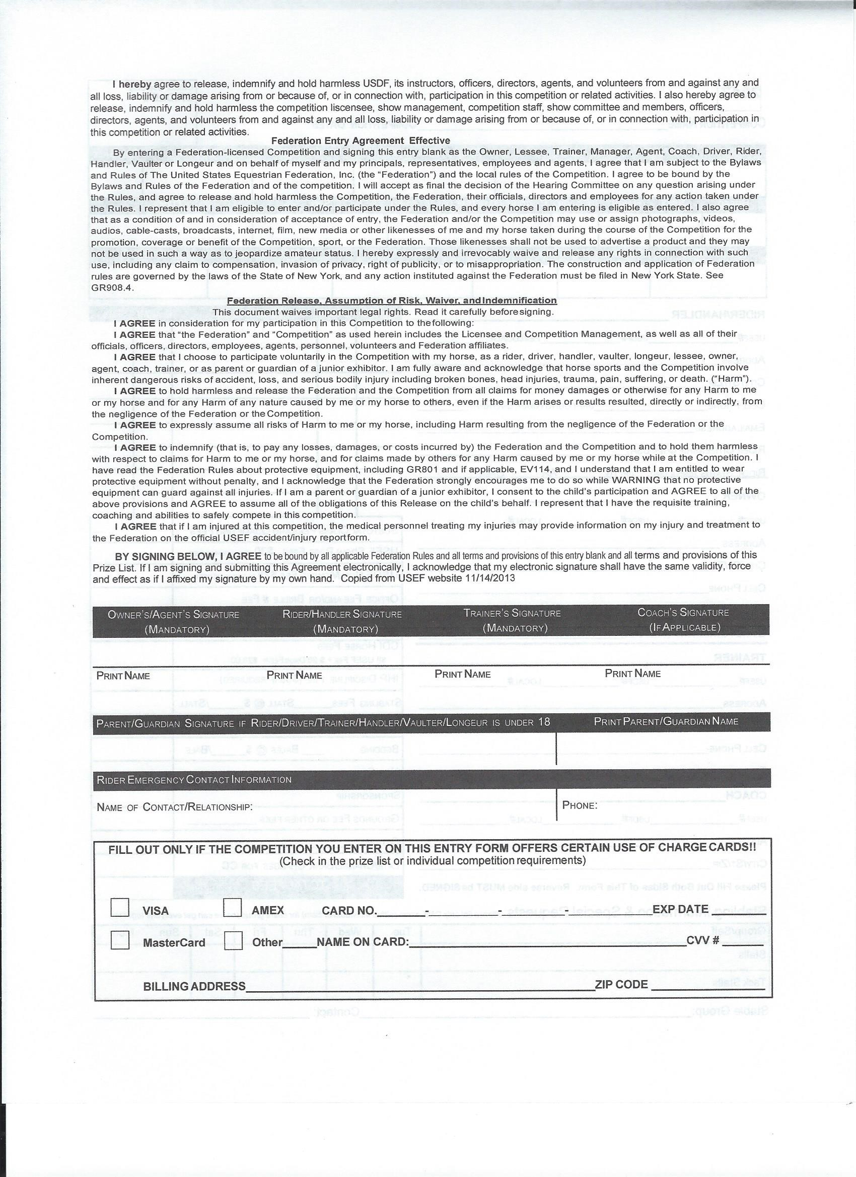
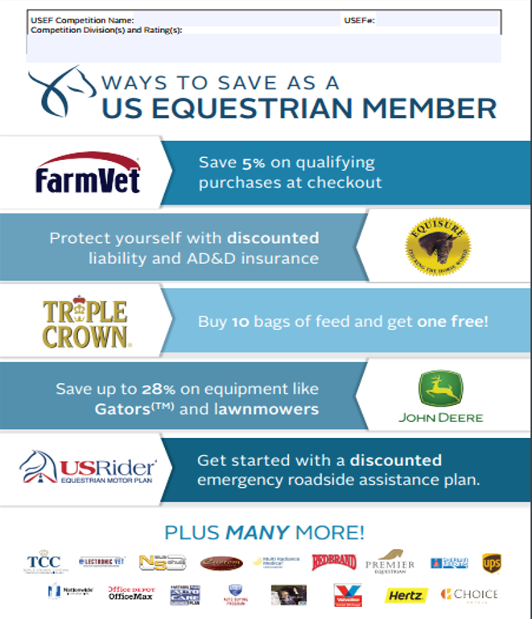
Dressage at Stone Tavern II 315027
USDF Training Level – Grand Prix, FEI tests Level 2 Competition

